**Assignment-6**

**Detailing the steps to upload a static website to Amazon S3.**

# **Uploading a Static Website in Amazon S3**

**Steps to follow:**

1. **Creating a public S3 bucket**
2. **Enabling static website hosting**
3. **Uploading files and modifying permissions**
4. **Accessing the website via a public URL**

**Remark**: Hosting a website on S3 requires making the files publicly accessible. Ensure no sensitive data is included.

# **Step 1: Sign in to AWS and Open Amazon S3 Console**

1. **Go to AWS** ([https://aws.amazon.com](https://aws.amazon.com/)) and sign in.
2. 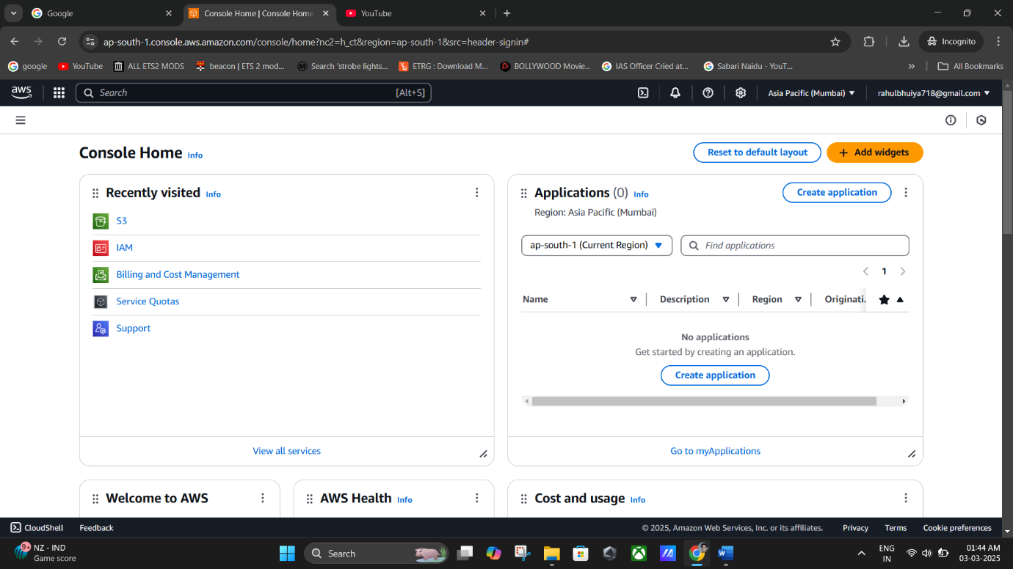In the **AWS Management Console**, navigate to **Amazon S3**.

**(AWS Console).**

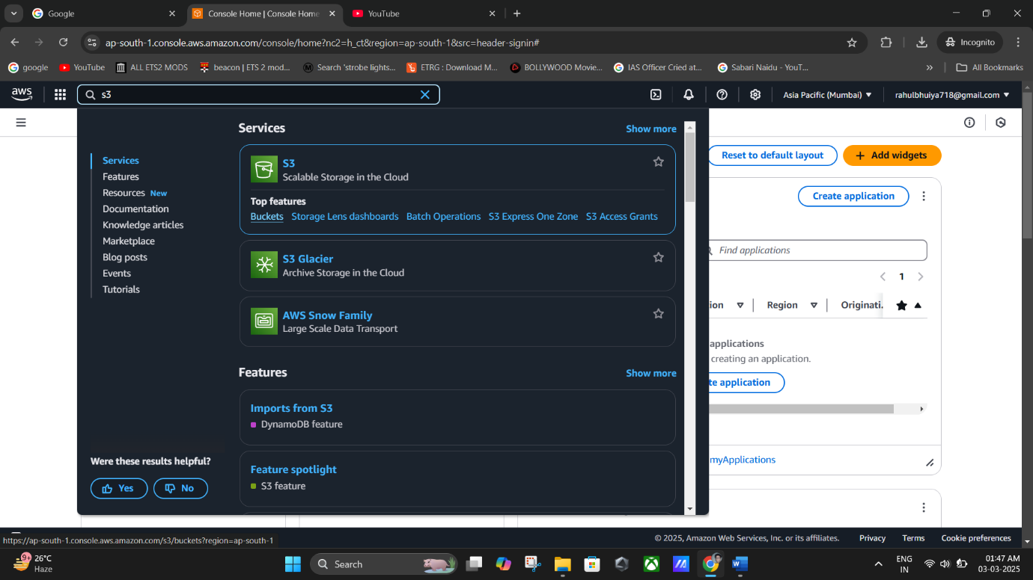

**(Navigate to Amazon S3).**

# **Step 2: Create a Public S3 Bucket**

1. In the left panel, click **Buckets**.
2. Click **Create bucket**.
3. The **Create bucket** page opens.
4. Enter a **Bucket Name** (e.g., rahulbhuiyabucket-1).
5. Choose the **AWS Region** where the bucket will reside.
6. **Enable ACLs** under **Object Ownership**.
7. **Modify Public Access Settings**:
   * Uncheck **Block Public Access settings for this bucket**.
   * Tick the **Acknowledgment** box.
8. 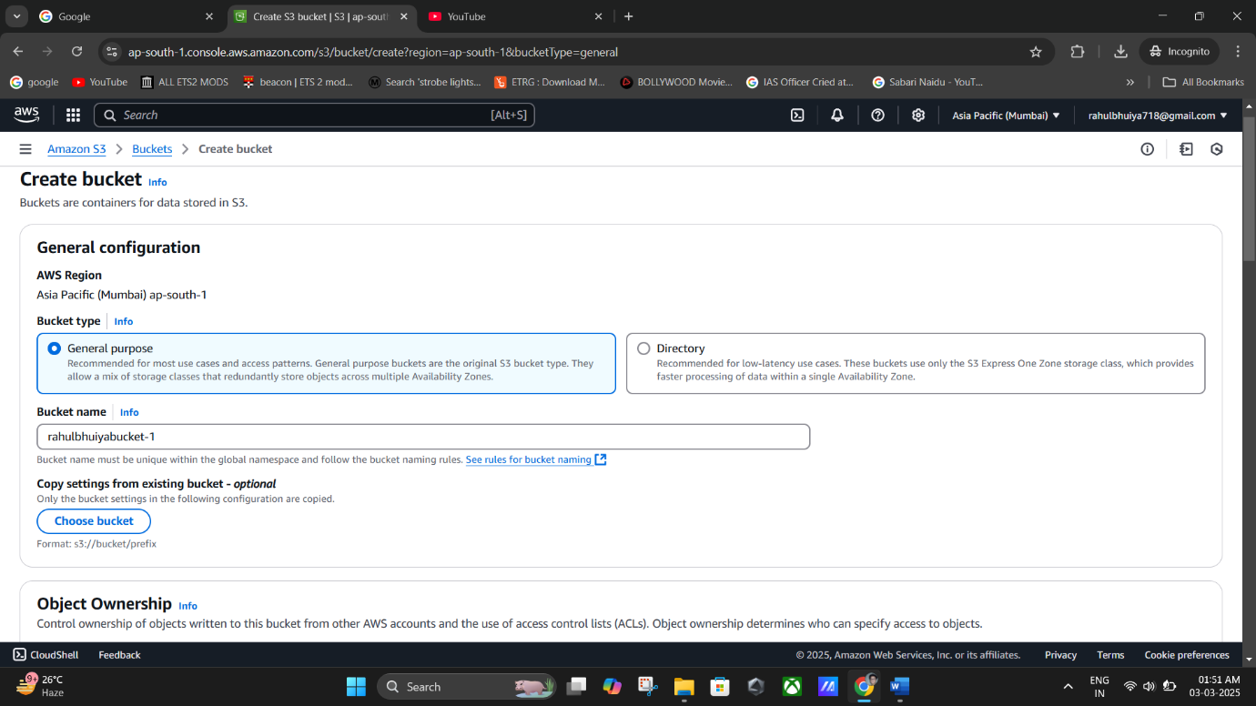Click **Create Bucket**.

**(Create Bucket_ Entering “Bucket Name”).**

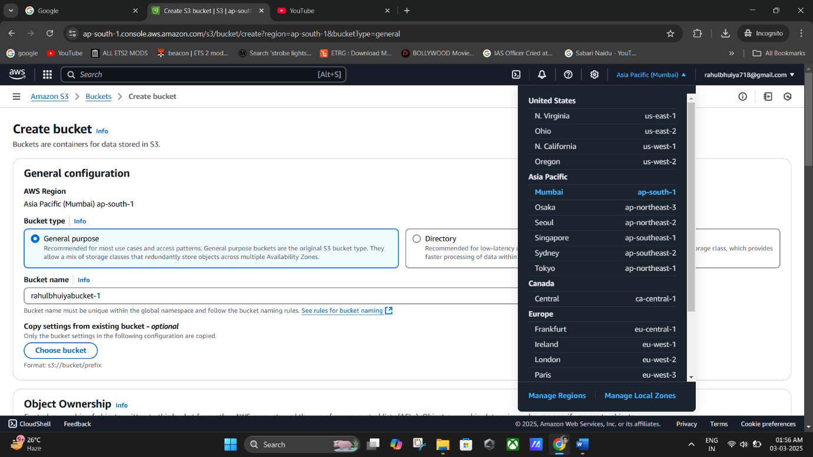

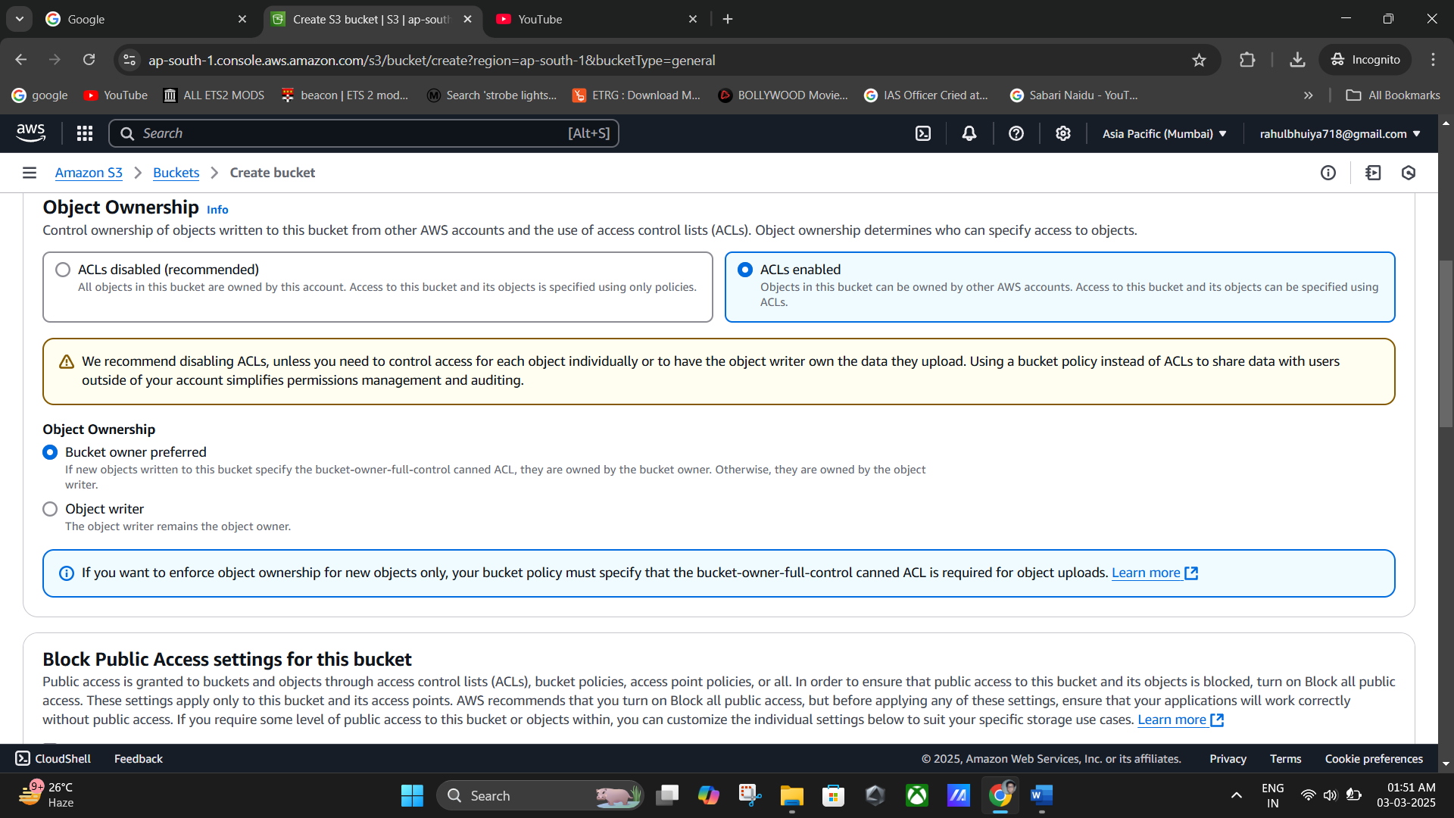

**(Choosing The AWS Region).**

(**Enable ACLs** under **Object Ownership**).

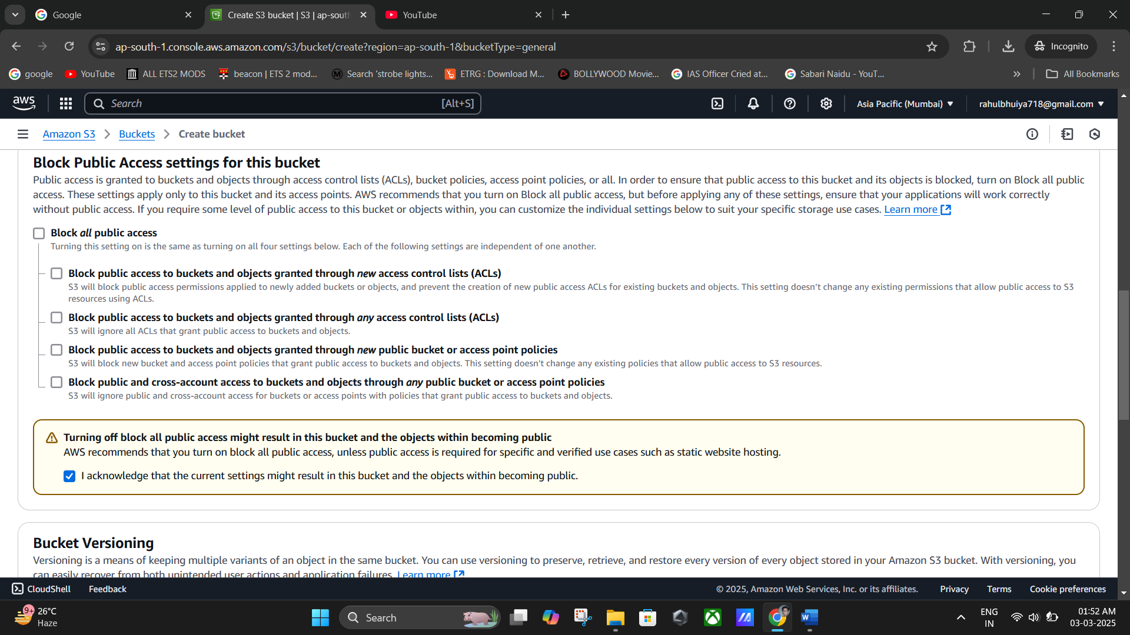

**(Uncheck Block Public Access settings for this bucket).**

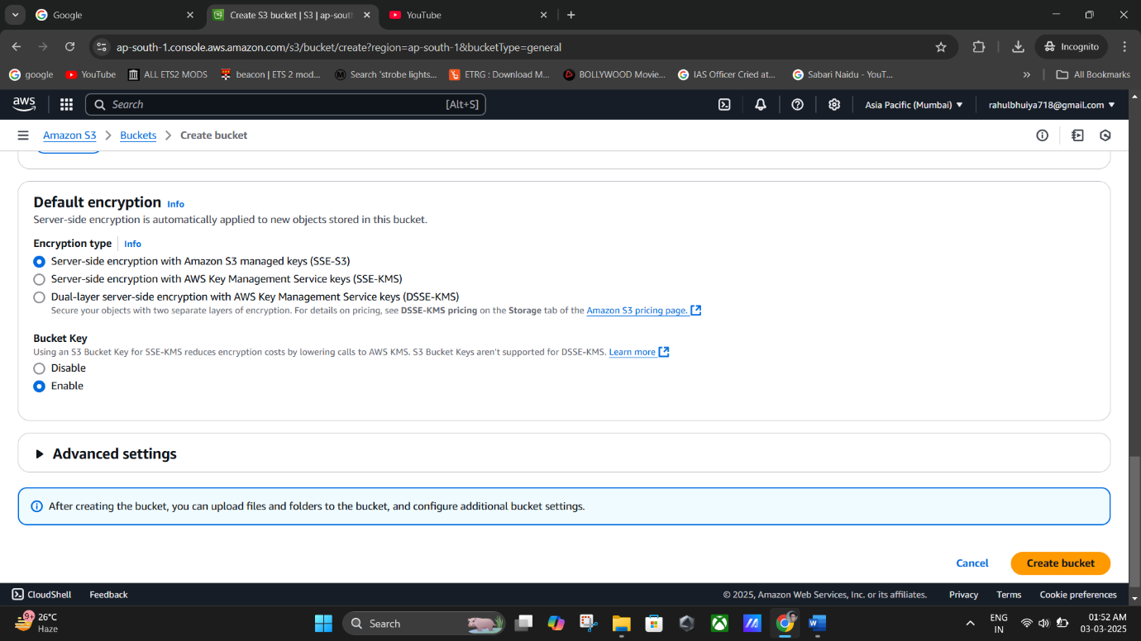

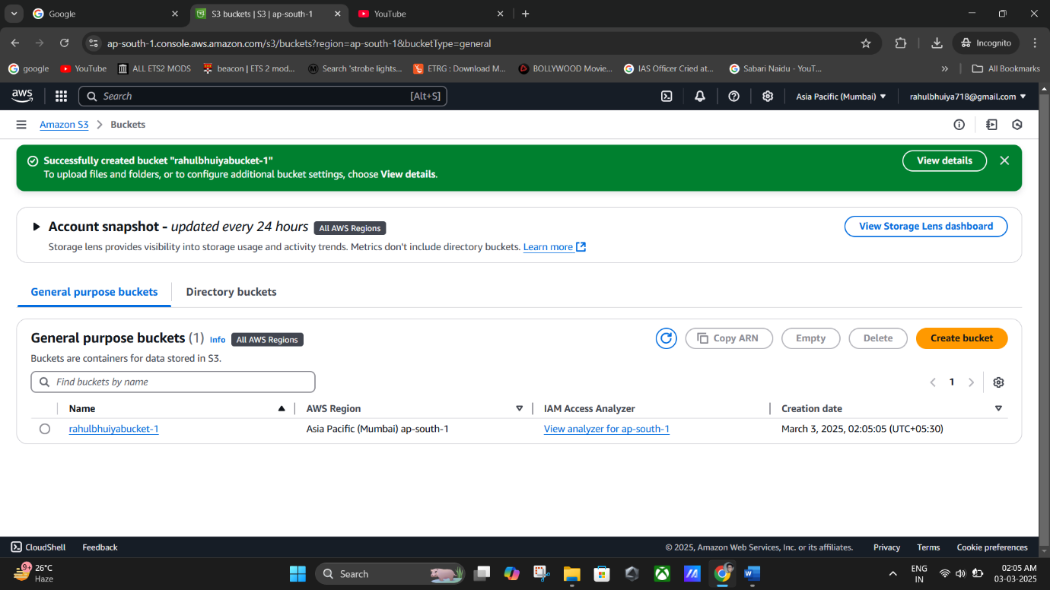

**(Bucket Created Successfully).**

**Remark**: The bucket itself is public, but individual files must also be made public.

# **Step 3: Enable Static Website Hosting**

1. Open the newly created bucket.
2. Go to the **Properties** tab.
3. Scroll down to **Static Website Hosting** and click **Edit**.
4. Enable **Static Website Hosting**.
5. Set the **Index Document** as index.html.
6. 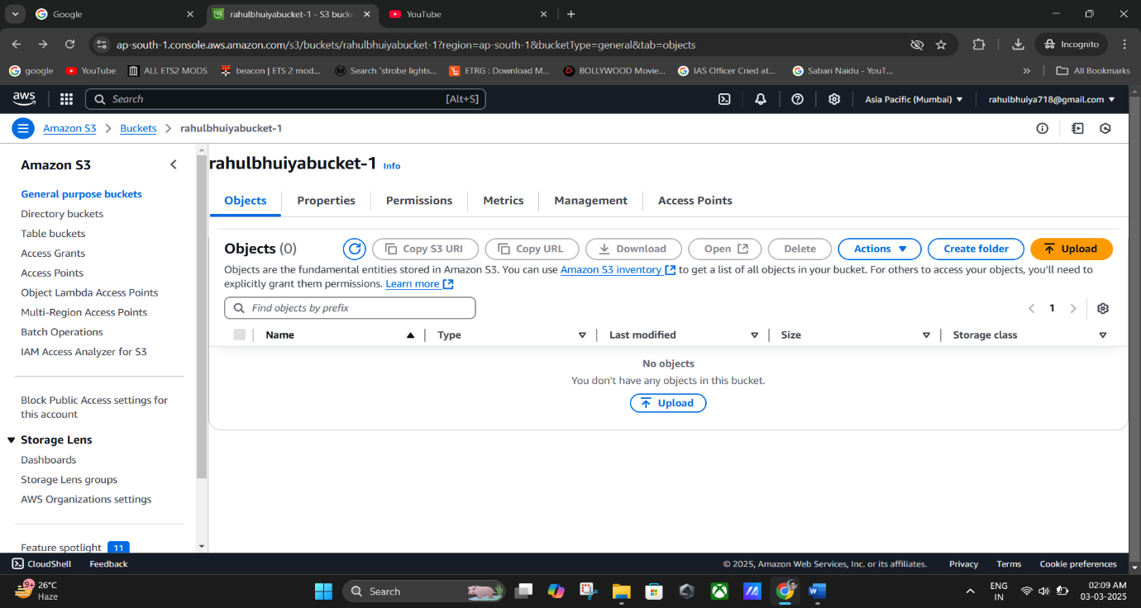Click **Save changes**.

**(“rahulbhuiyabucket-1” New Bucket Created).**

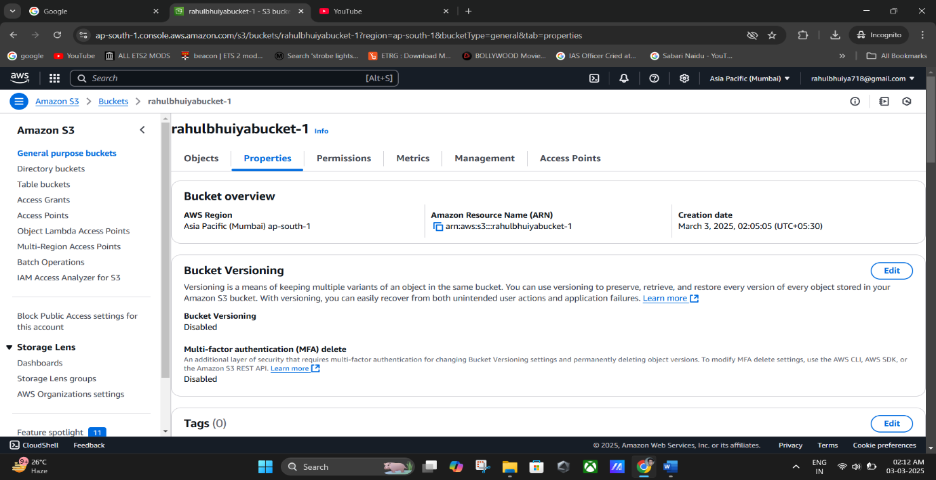

**(Properties Tab).**

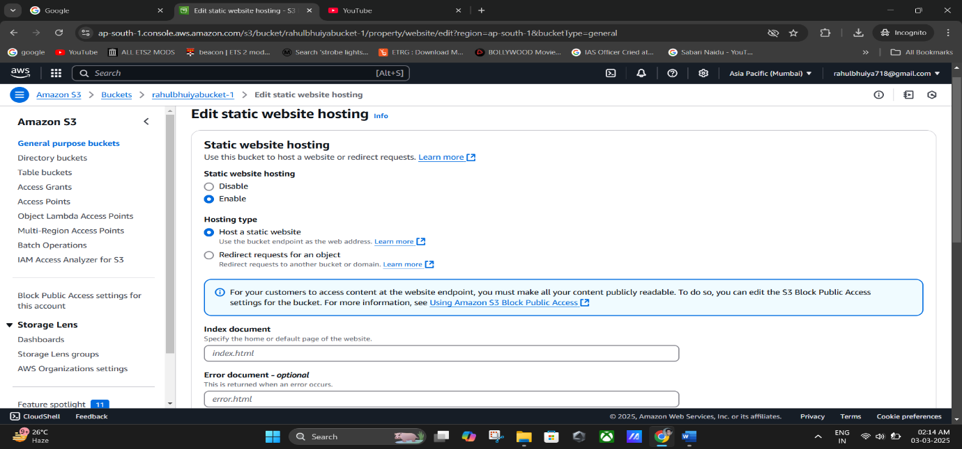

**(Static Web hosting Edited).**

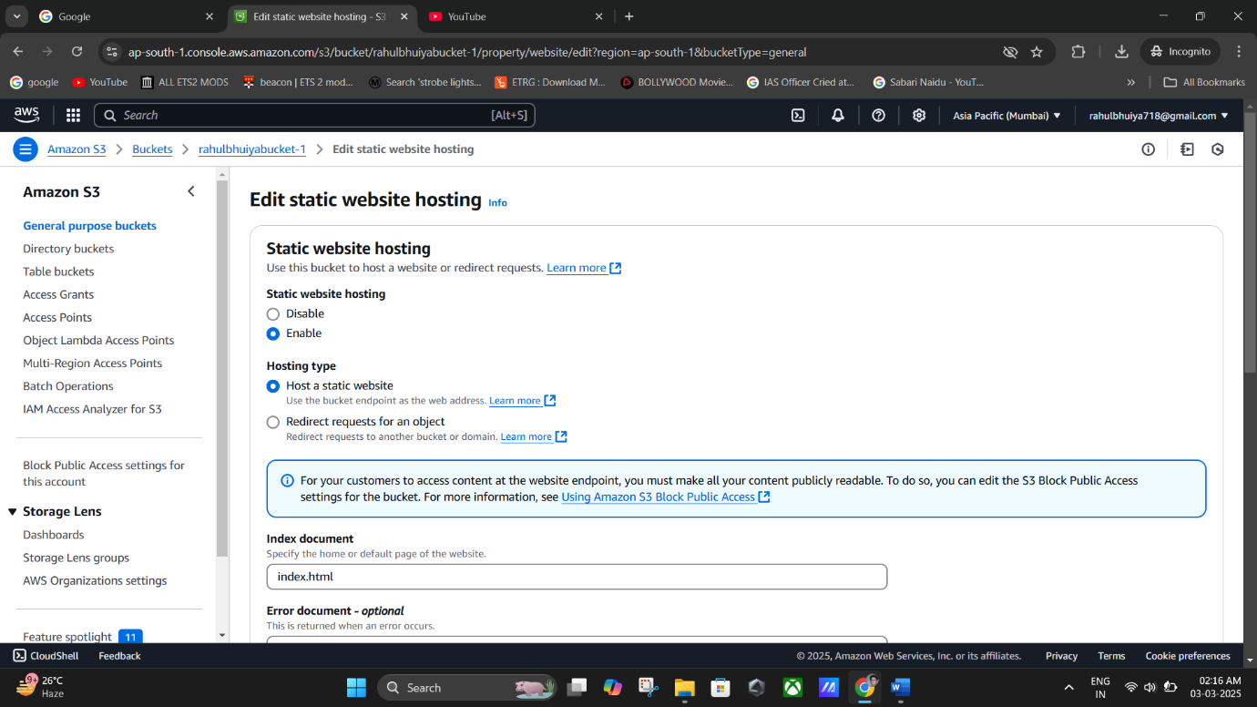

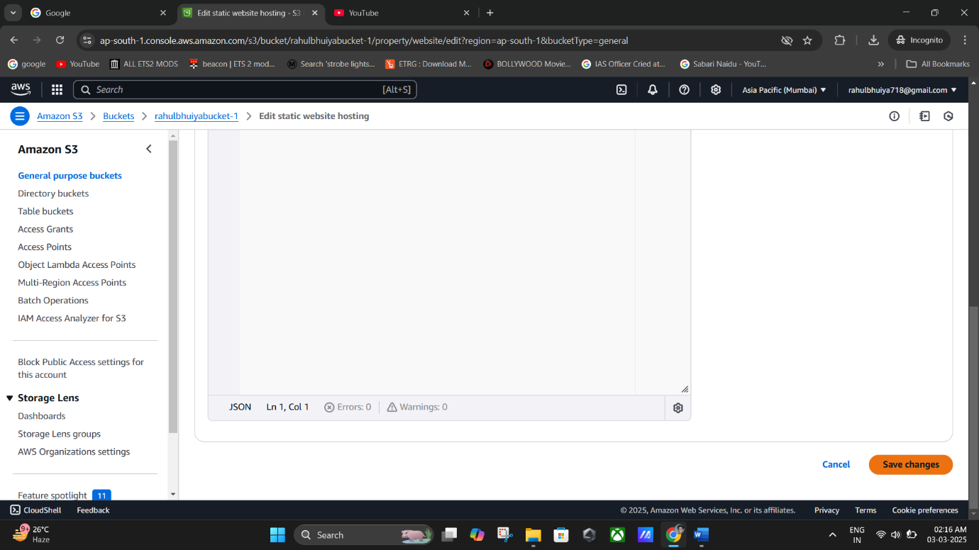

**(Setting the Index Document as index.html)**

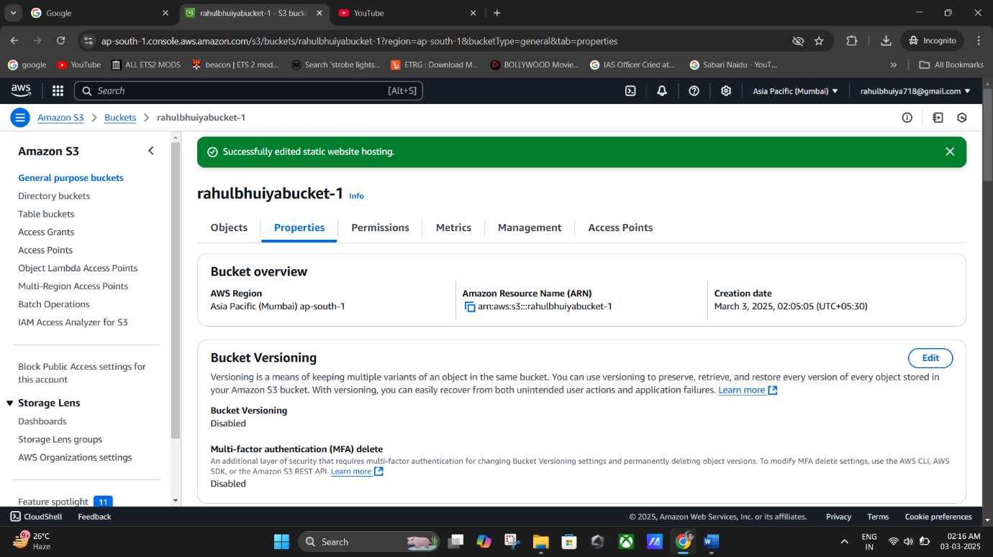

**(Successfully Saved the Changes).**

**Remark**: The **index.html** file will serve as the home page for the website.

# **Step 4: Upload Website Files**

1. Click **Upload**.
2. Click **Add folders** and select the folder containing the website files (index.html,

next.html, about.html).

1. 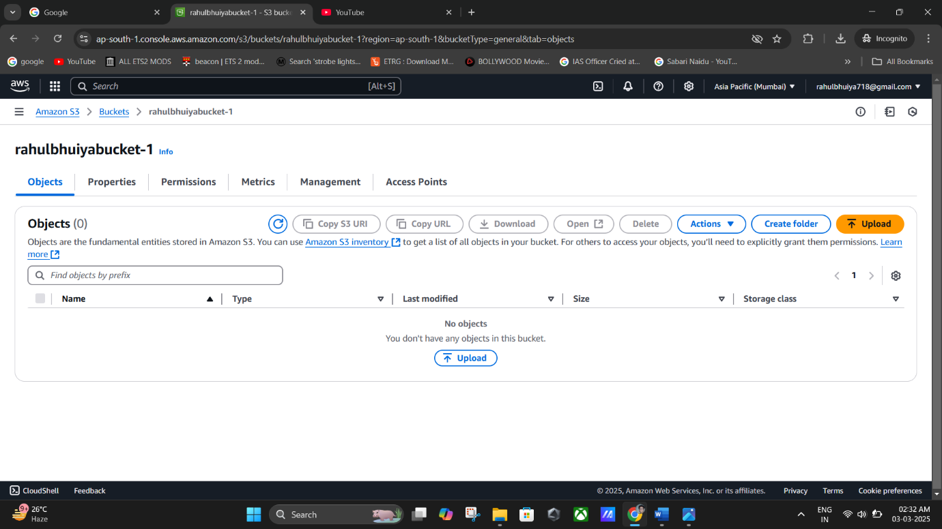Click **Upload** to complete the process.

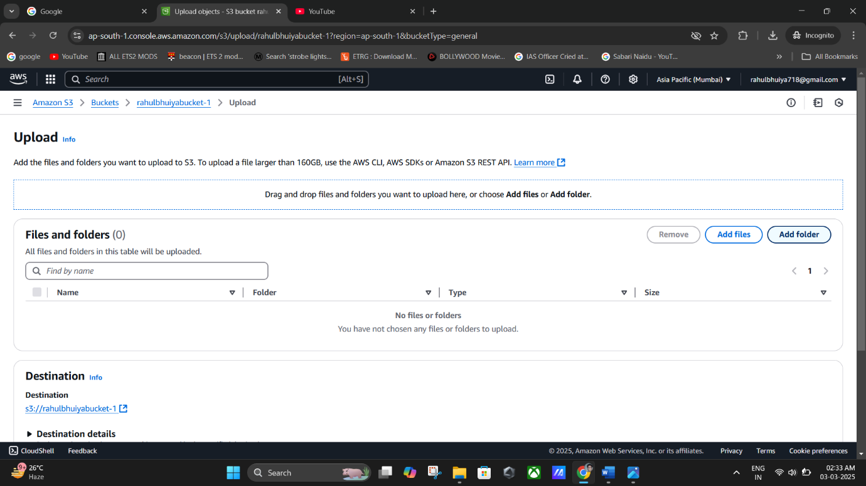

**(Upload Document).**

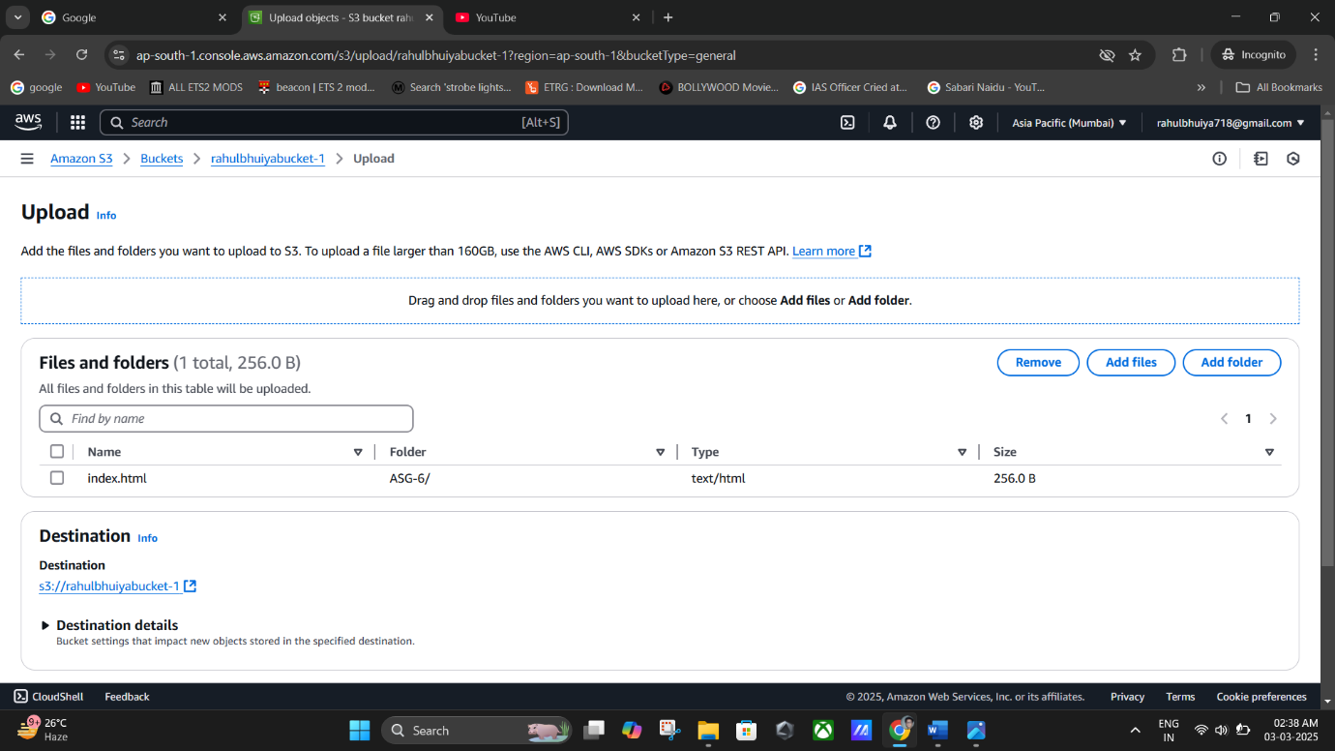

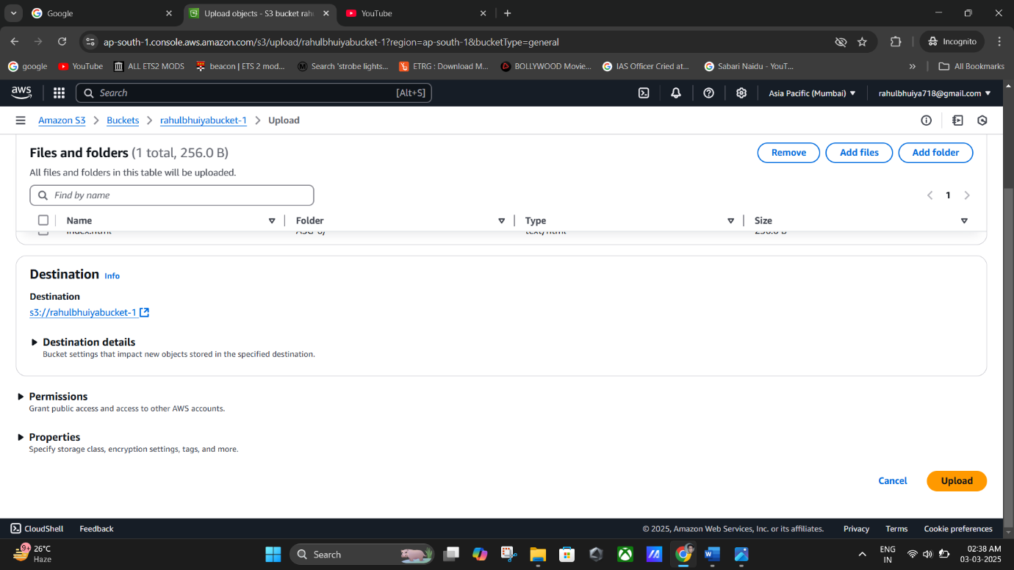

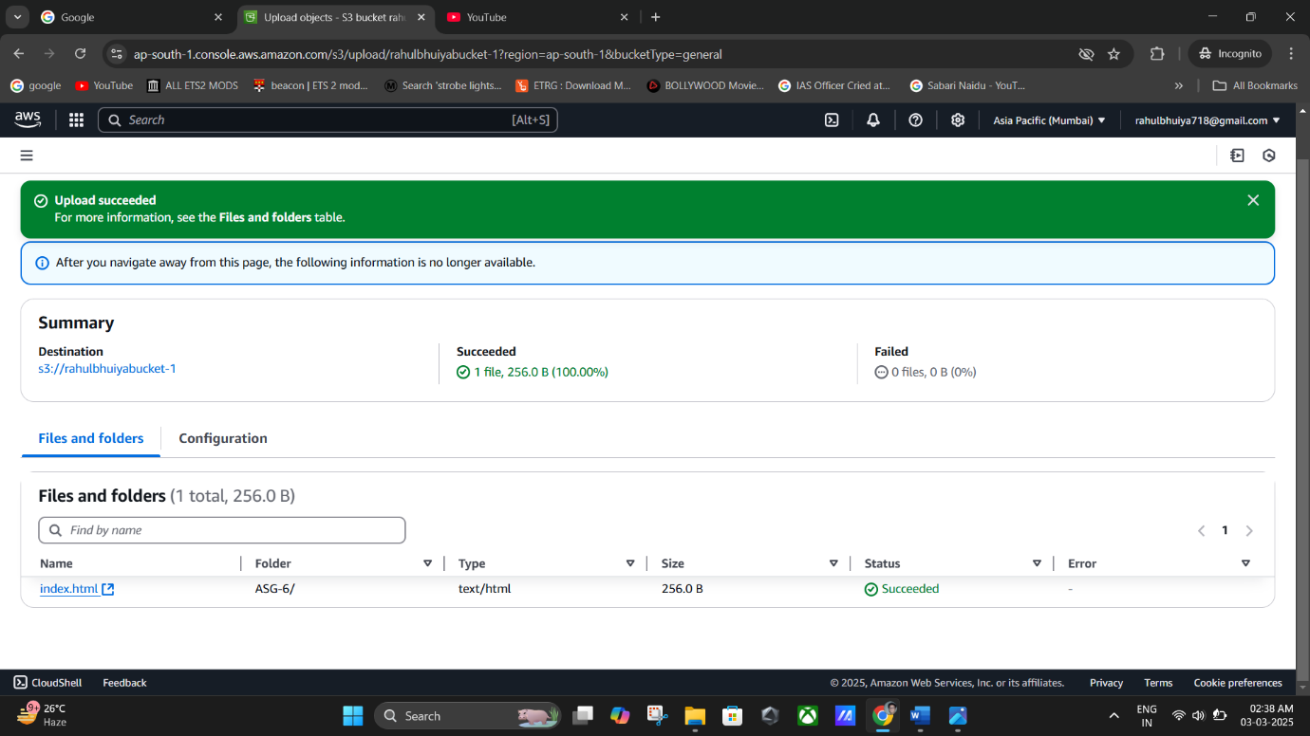

**(Successfully Uploaded the “index.html”).**

# **Step 5: Make Files Public Using ACL**

1. Select all uploaded files (index.html, next.html, about.html).
2. Click **Actions** → **Make public using ACL**.
3. 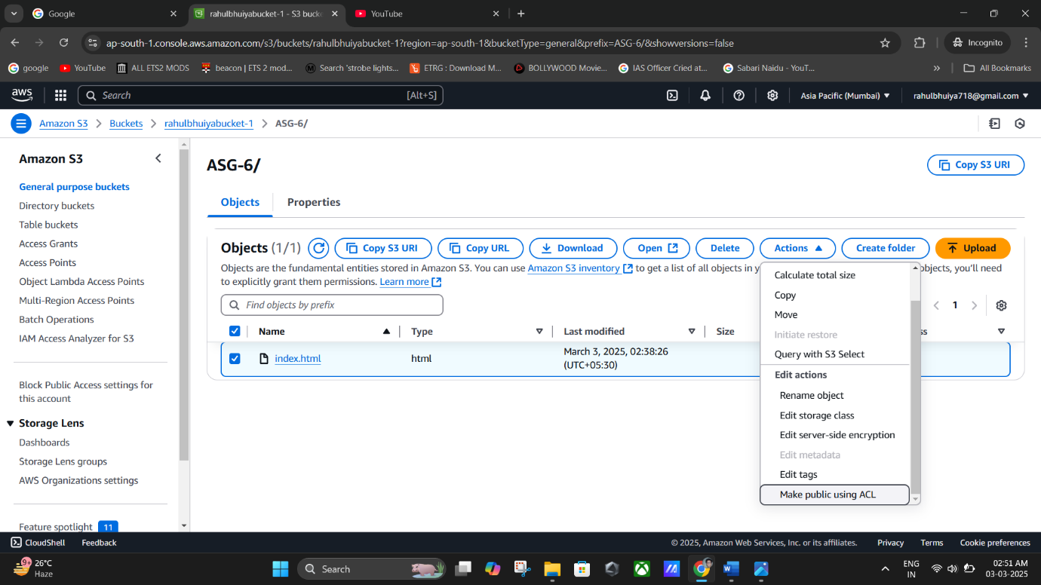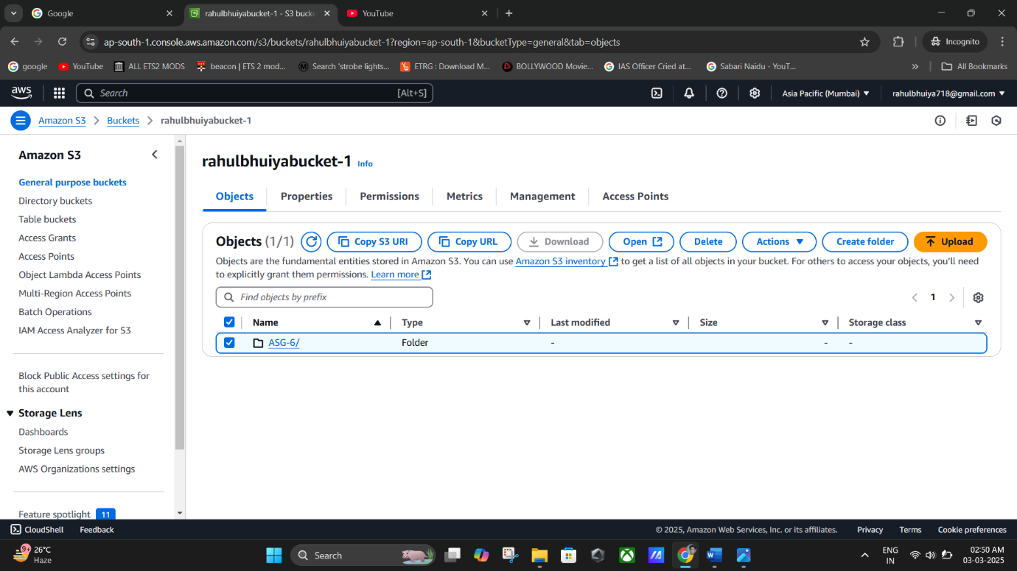In the **Make Public** page, click **Make Public**.

**(Click On Action).**

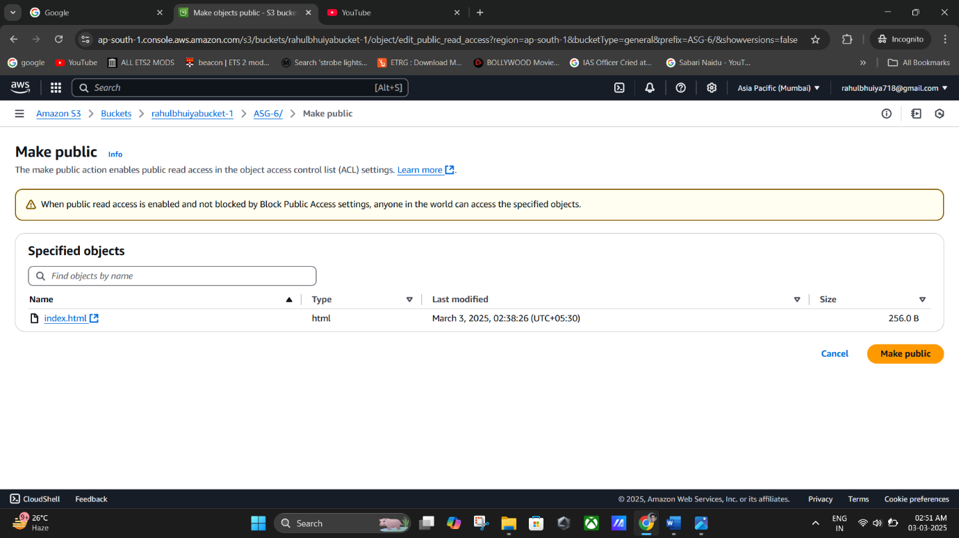

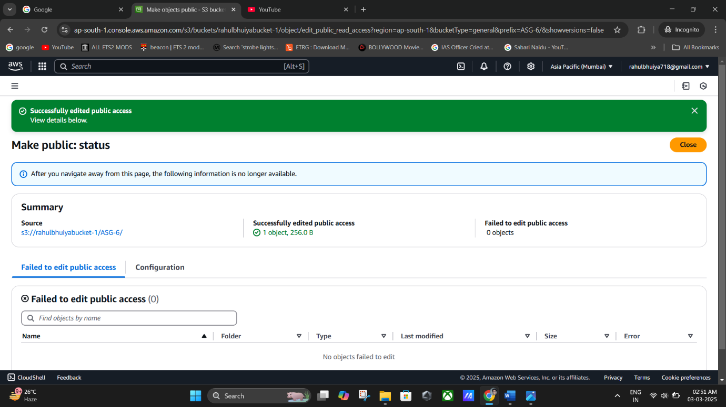

**(Public ALc Successfully Created).**

**(Make Public ALc).**

**Remark**: This step ensures that website files can be accessed by anyone.

# **Step 6: Access the Website**

1. Click on index.html.
2. Navigate to the **Properties** tab.
3. Under **Object Overview**, copy the **Object URL**.
4. Paste the URL in a web browser.
5. The static website should be visible.

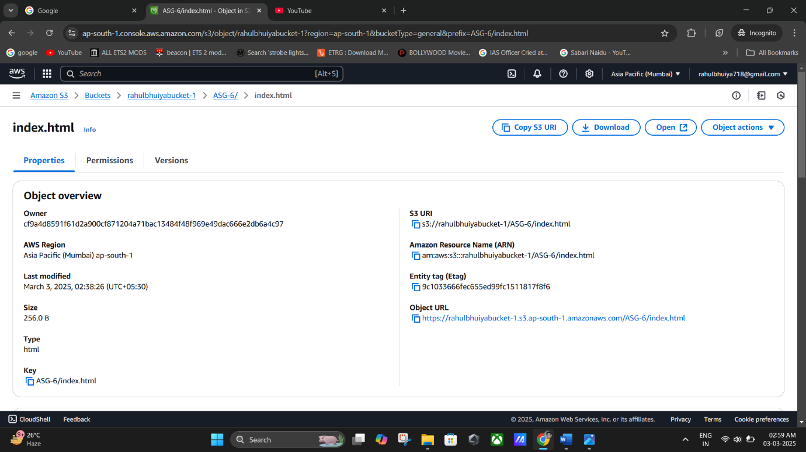

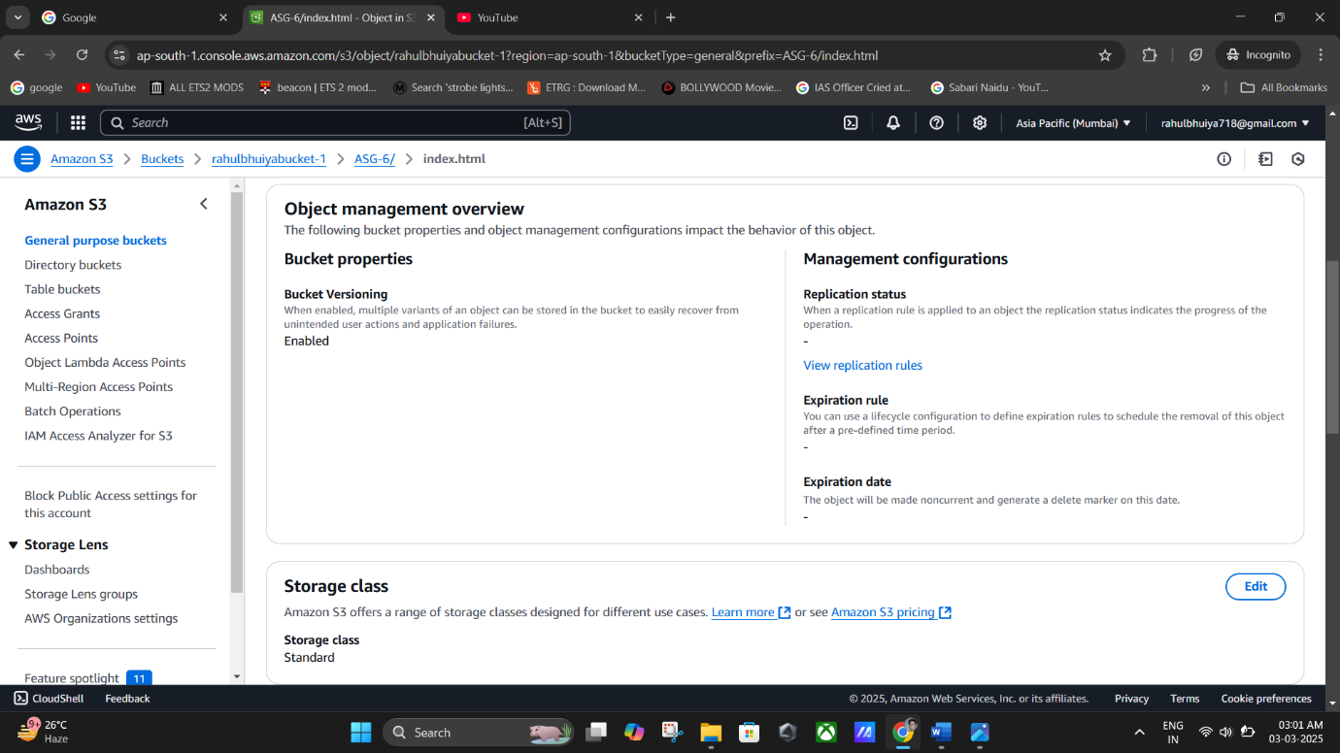

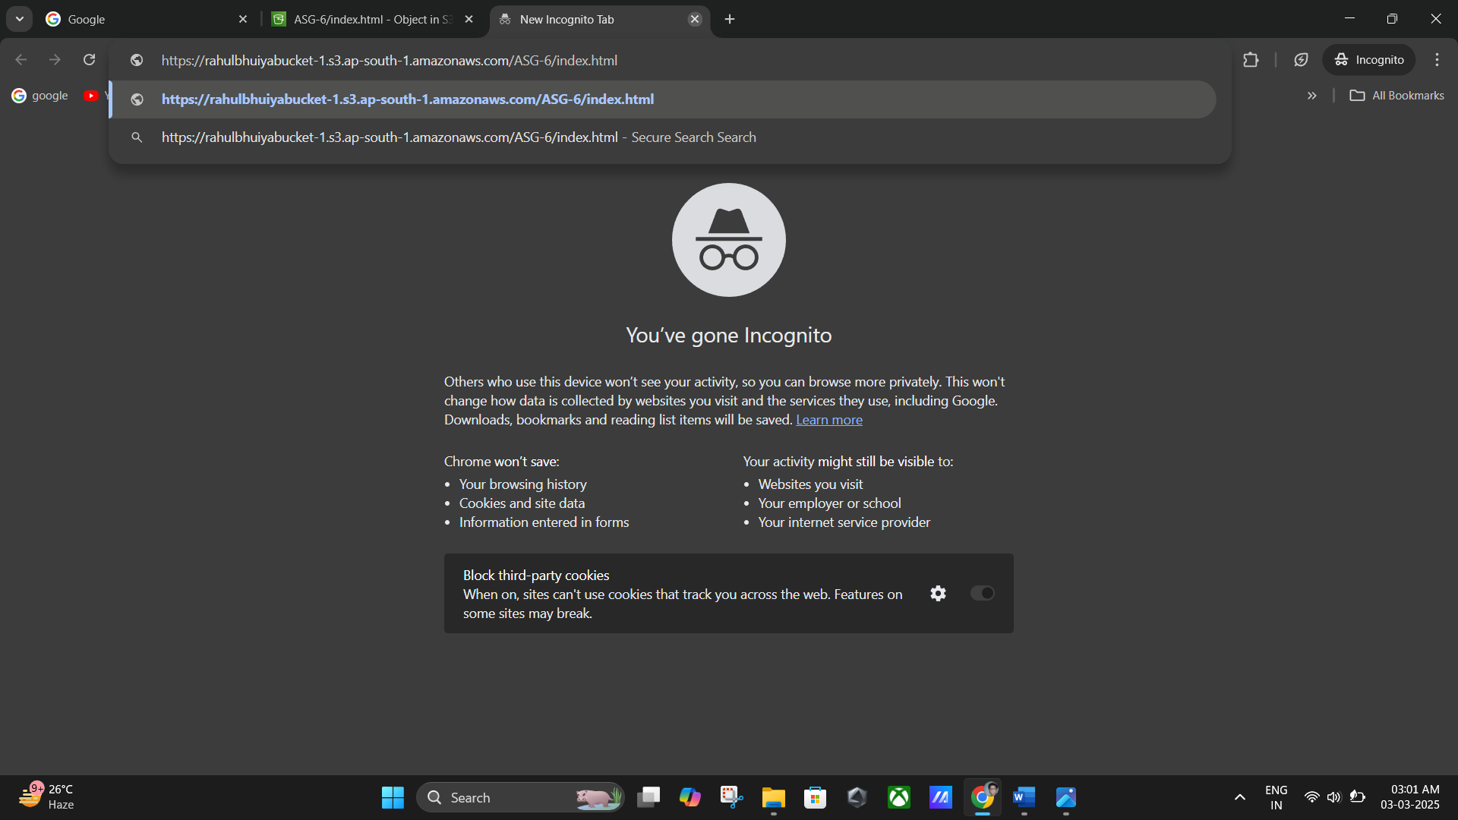

**(Object Overview, copy the Object URL).**

**(Pasting The URL in browser).**

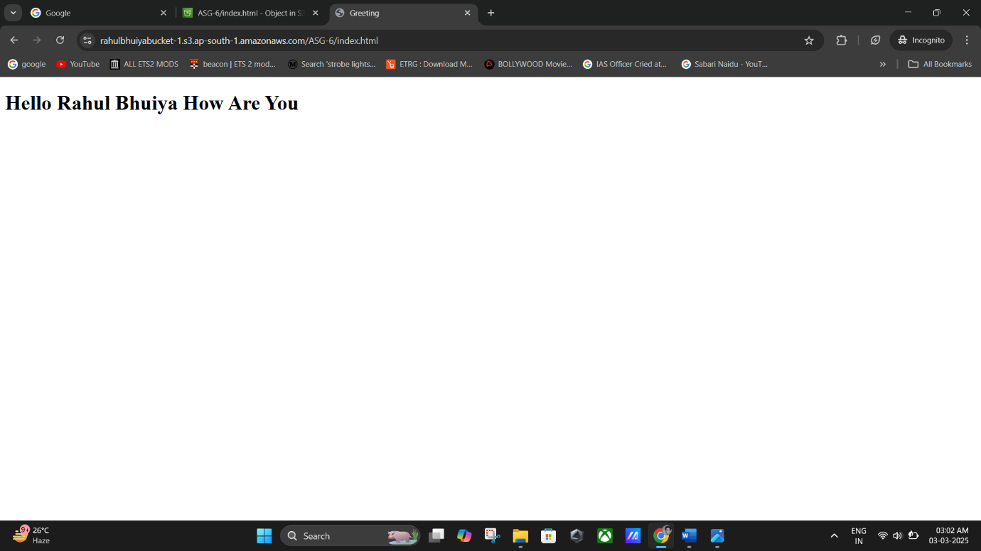

**(The Static Web Site is Visible).**

# Final Notes

* + **If the website does not load**, verify ACL permissions and ensure public access is enabled.
  + **The bucket name must be unique** globally in AWS.
  + **To use a custom domain**, configure Amazon Route 53 and set up a CNAME record.
  + **For additional security**, consider setting up AWS CloudFront.